www.shadowriders.org  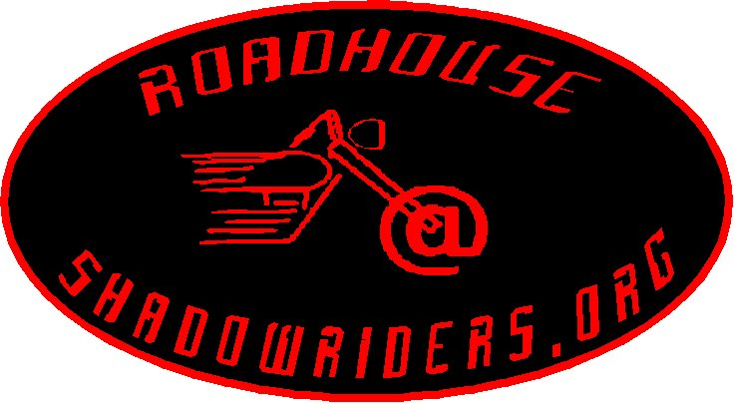  Marc W. Mauss 205 Devonshire Road Road Captain Hauppauge, NY 11788  marc@shadowriders.org (516) 582-1421 |  | www.shadowriders.org  Marc W. Mauss 205 Devonshire Road Road Captain Hauppauge, NY 11788  marc@shadowriders.org (516) 582-1421
www.shadowriders.org  Marc W. Mauss 205 Devonshire Road Road Captain Hauppauge, NY 11788  marc@shadowriders.org (516) 582-1421 |  | www.shadowriders.org  Marc W. Mauss 205 Devonshire Road Road Captain Hauppauge, NY 11788  marc@shadowriders.org (516) 582-1421
www.shadowriders.org  Marc W. Mauss 205 Devonshire Road Road Captain Hauppauge, NY 11788  marc@shadowriders.org (516) 582-1421 |  | www.shadowriders.org  Marc W. Mauss 205 Devonshire Road Road Captain Hauppauge, NY 11788  marc@shadowriders.org (516) 582-1421
www.shadowriders.org  Marc W. Mauss 205 Devonshire Road Road Captain Hauppauge, NY 11788  marc@shadowriders.org (516) 582-1421 |  | www.shadowriders.org  Marc W. Mauss 205 Devonshire Road Road Captain Hauppauge, NY 11788  marc@shadowriders.org (516) 582-1421
www.shadowriders.org  Marc W. Mauss 205 Devonshire Road Road Captain Hauppauge, NY 11788  marc@shadowriders.org (516) 582-1421 |  | www.shadowriders.org  Marc W. Mauss 205 Devonshire Road Road Captain Hauppauge, NY 11788  marc@shadowriders.org (516) 582-1421

